VLabs NITK

2DOF Forced Vibration

Validation document

2DOF System:

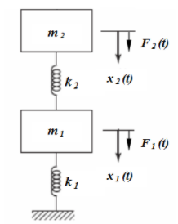

Equations used:



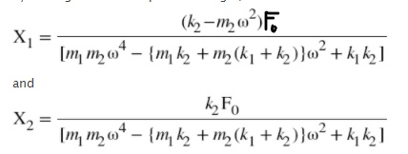

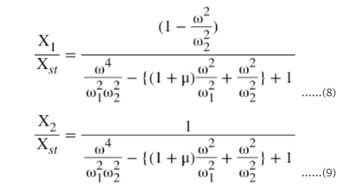

Initialised Parameters:

F0 = 750 N

M1 = 250 Kg

M2 = 50 Kg

K1 = 2500 N/m

K2= 500 N/m

Variable parameter :

ω = 5,10,12 rad/sec

Calculated values :

ωn1, X1, X1/δst

|  |  |  |  |  |
| --- | --- | --- | --- | --- |
| Iteration No. | ω | ωn1 | X1 | X1/δst |
| 1 | 5 | 2.53326 | -.257143 | -.8571 |
| 2 | 10 | 2.53326 | -.034177 | -.1139 |
| 3 | 12 | 2.53326 | -.022753 | -.0768 |

Questions (Before simulation)

1. The Degree of Freedoms of a system determines it’s:
2. Number of springs
3. Number of natural frequencies
4. Number of harmonics
5. Number of fixed support

Ans:b. Number of natural frequencies

2. For the MDOF system the roots of governing differential equations are:

1. Equal
2. Eigen Values
3. Non-Zero
4. Complex number

Ans: b. Eigen Values

3. Which of the following is an example of a 2DOF system:

1. A Uniform Cantilever beam fixed at one end
2. An automobile suspension system with 4 springs for each wheel
3. Two masses connected via uniform spring
4. An anvil paced on a pad kept on a foundation which is standing on the sand

Ans: d.An anvil paced on a pad kept on a foundation which is standing on the sand

### **4. Theoretically, the number of modes of a steel scale held at one end (cantilever)**

* None of these
* 1
* 0
* ∞
* Ans: d. infinity

Questions (After simulation)

1. How many points of infinitely large amplitudes (resonance condition) exist for the graph of X1 vs ω/ωn2 :
2. One
3. Two
4. Three
5. Infinitely many

Ans: b. two

**2. For effective isolation, frequency ratio should be greater than**

* 1
* 0.707
* 1.414
* None of these
* Ans: c. 1.414